Booking Form

Name ____________________________

Job Title ____________________________

Employer ____________________________

Address ____________________________

____________________________

____________________________

Telephone ____________________________

Fax ____________________________

E-mail ____________________________

Conference Fee €350

No refunds for cancellations within 10 days of Conference

Local Authority Order No. _________________
or
Amount enclosed € ______________________

Cheques should be crossed and made payable to:

Irish Building Control Institute
P.O. Box 3667,
Dublin 4.

For further information, please contact:
Tom Johnson, Conference Director

Tel 086 8151387
Email thomasjohnson43@gmail.com

Please fill out a separate form for each participant Photocopy as required

Speakers

Sarah Neary, Principal Advisor, Department of Housing, Planning, Community and Local Government

Mairead Phelan, Chartered Engineer, Project Manager, National Building Control Office

Michael Mansell, Civil Engineer and Building Control Officer in Cork City Council

Doug Richie, Bachelor of Building Science and Building Control Manager at Homebond

John Wickham, Senior Building Standards Advisor, Department of Housing, Planning, Community and Local Government

Eamonn Smyth, Building Standards Advisor, Department of Housing, Planning, Community and Local Government.

Jonathan Jennings, Director, Heating and Ventilation Division, Glen Dimplex Ireland

Colin Gallagher, Senior Executive Engineer, Member of IBCI and Building Control Officer at Fingal County Council

Alan O Neill, Acting Chief Fire Officer,
Carlow County Council

The Irish Building Control Institute
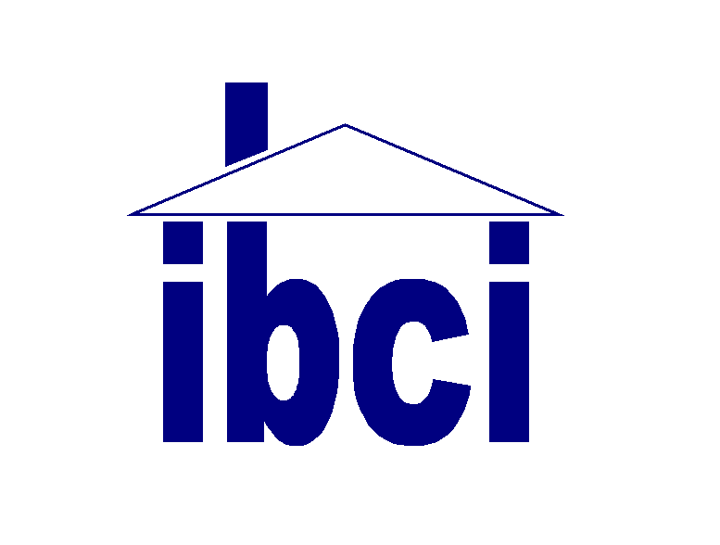

IBCI
Building Control
Conference
2019

27th and 28th March 2019

The Lyrath Estate, Paulstown Road, Kilkenny

Who should attend?

Building Control Officers, Fire Officers,
Building Surveyors, Access Officers
Engineers, Architects, Building Inspectors, Housing Inspectors, and Administrative Staff
involved with Building Control in Central and Local Government
Day 1: Wednesday, 27th March 2019
09:00 – 09.45 REGISTRATION and
Coffee and TRADE SHOW Viewing

10.00 Welcome and Official Opening of
Conference by Bernadette McArdle
President, IBCI

Session 1: Chaired by Bernadette McArdle
President IBCI

10.15 Building Control Legislative Developments
Sarah Neary

11.00 TRADE SHOW Viewing and Coffee

11.30 Building Control Management Project
Latest Developments Mairead Phelan

12.00 Assigned Certifier Perspective
Doug Richie

12.30 Building Control Officer Perspective
Michael Mansell

13.00 LUNCH and TRADE SHOW Viewing

Session 2: Chaired by Sheila Broderick
Vice President IBCI

14.00 INDUSTRY presentations
(5 minutes max. First 8 exhibitors to book)

14.45 “Bringing Back Homes” – A manual for the reuse of existing buildings
John Wickham
15:15 TRADE SHOW Viewing and Coffee

15.45 Fire Safety Guidance
Eamonn Smyth

16.15 QUESTIONS and SOAPBOX

19.30 Conference Dinner reception
20.00 Conference Centre Dinner
Day 2: Thursday, 28th March 2019

09:00 TRADE SHOW Viewing

Session 3: Chaired by Kevin Sheridan
Past President IBCI

09.30 Heat Pumps and Renewable
Technologies Jonathan Jennings

10.45 TRADE SHOW Viewing and Coffee

Session 4: Chaired by Johnny Mc Gettigan
Past President, IBCI

11.15 Part L Compliance - Building Control
Role
Colin Gallagher

11:45 Challenges in Fire Prevention -
Case Study
Alan O Neill
12.30 Questions

12.45 Close of Proceedings

12.45 LUNCH

The Irish Building Control Institute welcomes people with disabilities. If you have any special mobility, dietary or communication requirements please outline your request at time of booking and at least 7 days before Event so that we can endeavour to facilitate you.

There will be ample time for discussion and debate over the course of the two days.

IBCI Conference 2019

The Irish Building Control Institute is pleased to present the IBCI Building Control Conference, 2019. The Conference will afford an opportunity for those involved in Building Control throughout Ireland to network with their colleagues and receive an update on current developments.

The Conference will be held over two days in the Lyrath Estate, Kilkenny. Lunch and refreshments will be provided on both days, with the Conference Dinner on the Wednesday evening. A Trade Exhibition will also be held in conjunction with the Conference.

The focus of this Conference is on the changes in the Building Control System and the Building Regulations and developments in the past year.

Day 1 morning session will include an update on the Building Control legislation/Regulations, on the BCMP followed by Building Control Officers and Assigned Certifiers perspectives.

After lunch the session will commence with short 5 minute slots for the Trade Exhibitors (45 mins max). Next, we hear about the strategy and guidance for utilising existing buildings through the Bringing Back Homes initiative.

After coffee, the final session of Day 1 will provide an overview of guidance available on Fire Safety. Day 1 concludes with questions and the Soapbox.

Day 2 commences with a double presentation on renewable technologies and heat pumps. After coffee break we have a paper on Part L outlining the role of building control and we conclude with a case study on fire prevention.

IBCI CPD Certificates will be available.

